10th December 2019

**Indian National Wins US$1 Million Dollar in Dubai Duty Free Draw**

* ***While three other winners will drive away a stylish motorbike each***

**Summary:** A lucky Indian national living in Saudi Arabia, Mr. Sakeer Hussain Srambikkal, has become US$1 million dollar richer after winning the Dubai Duty Free Millennium Millionaire promotion in Series 317 which was held today at Al Maktoum International Airport.

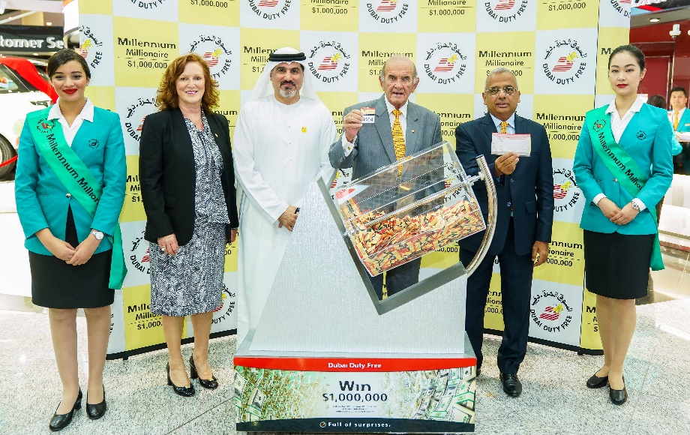

The Dubai Duty Free Millennium Millionaire draw for Series 317 was conducted by Colm McLoughlin, Executive Vice Chairman & CEO, Ramesh Cidambi, COO, Salah Tahlak, Executive Vice President – Corporate Services, Sinead El Sibai, SVP – Marketing at Al Maktoum International Airport.

A lucky Indian national living in Saudi Arabia, Mr. Sakeer Hussain Srambikkal, has become US$1 million dollar richer after winning the Dubai Duty Free Millennium Millionaire promotion in Series 317 which was held today at Al Maktoum International Airport.

The 46-year-old supervisor for Middle East Airline in Dammam couldn’t believe that his ticket number 3464 that he purchased online brought him a million surprise.

“What a great way to start my day”, said Mr Srambikkal who was ecstatic when he received an early morning call from Dubai Duty Free.

“It was my second ticket in the million-dollar promotion and I am so thankful to Dubai Duty Free for this amazing win”, added Mr Srambikkal.

Furthermore, three Finest Surprise draws were conducted directly after the Millennium Millionaire with each winner driving away a stylish motorbike.

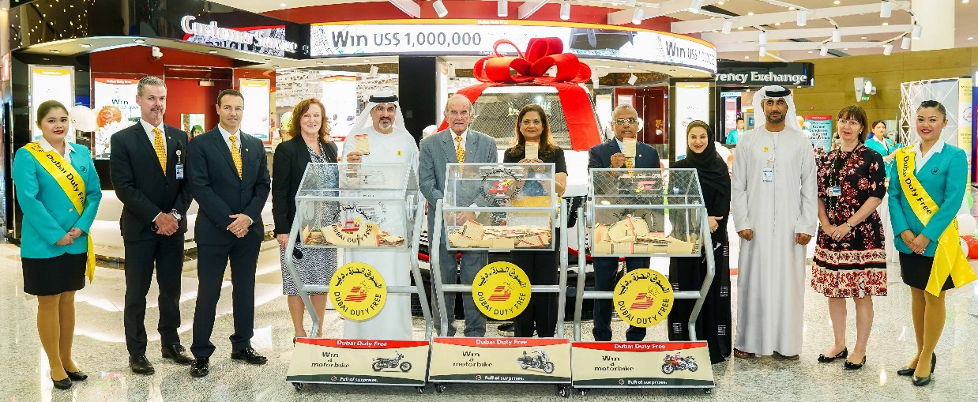

The  three Dubai Duty Free Finest Surprise motorbikes draw for Series 388, 389 and 390 was conducted by Dubai Duty Free senior officials: Colm McLoughlin, Executive Vice Chairman & CEO, Ramesh Cidambi, COO, Salah Tahlak, Executive Vice President – Corporate Services, Sinead El Sibai, SVP – Marketing, Bernard Creed, SVP – Finance, Saba Tahir, SVP – Purchasing, Mona Al Ali, SVP – HR, Michael Schmidt, SVP – Retail Support, Sharon Beecham, VP - Purchasing and Zayed Al Shebli, VP – Loss Prevention and Corporate Security at Al Maktoum International Airport.

Mr. Deepak Gunasekaran, a 29-year-old Indian national based in Dubai, won a Moto Guzzi VY Racer (Racer) in Series 388 with ticket number 0889.

A yoga instructor and resident of Dubai for four years, Mr. Gunasekaran purchased two tickets online for Series 388 and was equally delighted on hearing the good news.

“I’ve been participating in Dubai Duty Free promotions for a year now and winning for the first time was a surreal experience. Dubai Duty Free is changing many people’s lives and I’m very lucky that I am one of them.”

Another winner is Ms. Razia Sultana Siddiqui Hakimullah, a Pakistani national based in Sharjah, who won an Aprilla Tuono RR (Nero) in Series 389 with ticket number 0415 that her son bought under her name.

“I’ve been living in the UAE for 40 years and was fortunate for the opportunity this country has given me and my family. To win something from Dubai Duty Free is one of them, so thank you so much.”

Another winner to take home a Motto Guzzi California (Nero Gentleman) is Ms. Vijaya Lakshmi, a 42 year old Indian national from Sharjah who won in Series 390 with ticket number 0049.

Ms. Lakshmi and her family are regular participants to Dubai Duty Free’s Finest Surprise promotions for around 15 years now and are all very happy and thankful that their perseverance has paid off.

A resident of Dubai for twenty-five years, Ms Lakshmi works as a head of partnership for You Got a Gift – an online mall for gift cards.

“I’ve been trying my luck for a long time, but I guess luck is not on my side, so I wanted to let go but my husband has persuaded not to give up. Good thing I listened to him. Thank you for this win.”

Today’s draw was conducted by Dubai Duty Free senior officials: Colm McLoughlin, Executive Vice Chairman & CEO, Ramesh Cidambi, COO, Salah Tahlak, Executive Vice President – Corporate Services, Sinead El Sibai, SVP – Marketing, Bernard Creed, SVP – Finance, Saba Tahir, SVP – Purchasing, Mona Al Ali, SVP – HR, Michael Schmidt, SVP – Retail Support, Sharon Beecham, VP - Purchasing and Zayed Al Shebli, VP – Loss Prevention and Corporate Security.

* Ends -

For further information, please contact Bernard Aquino, Marketing Department,

Dubai Duty Free or call Tel: +9714-6019232 or email: [bernard.aquino@ddf.ae](mailto:bernard.aquino@ddf.ae)